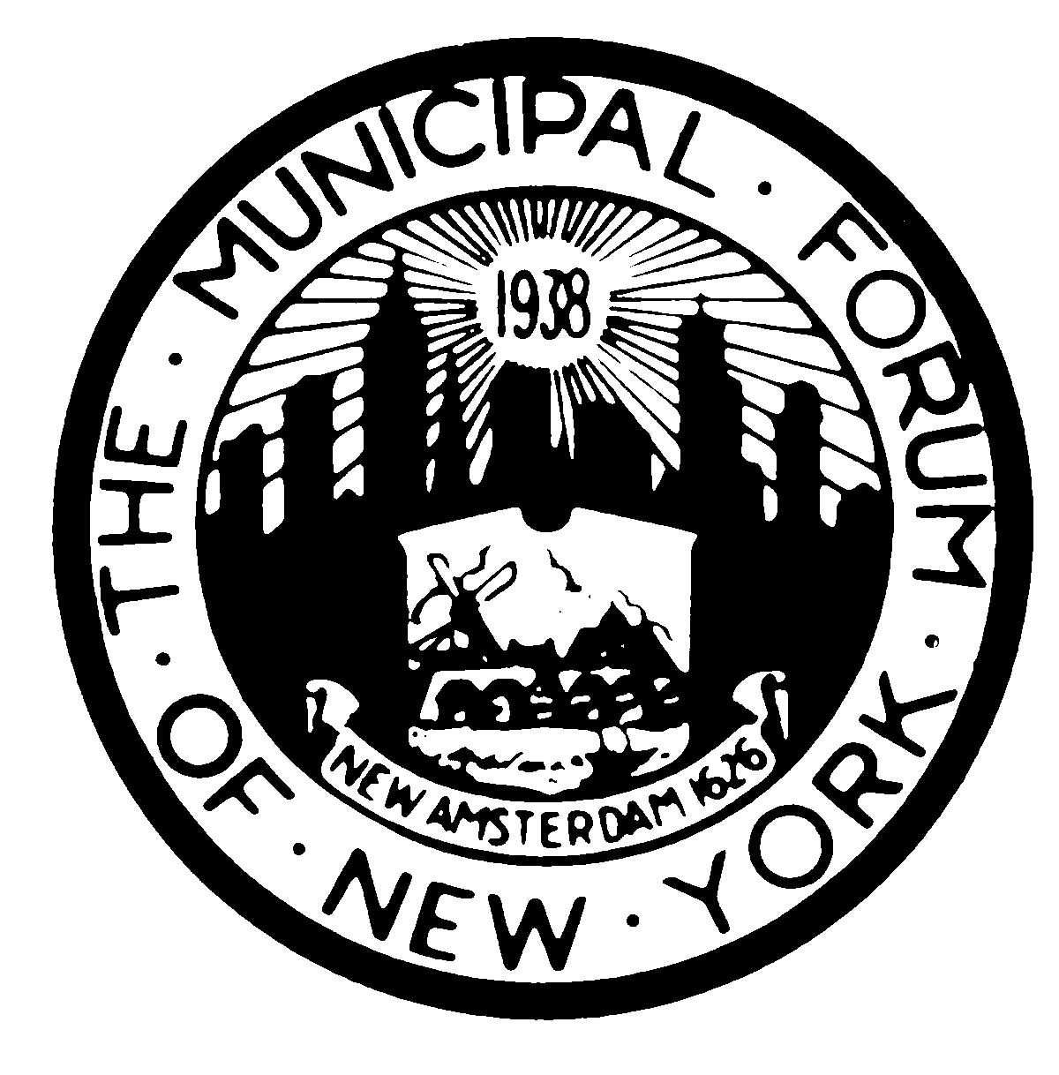 | The Municipal Forum of New York  -Established 1938- www.themunicipalforumofnewyork.org  October 2019  TO: The Membership Committee of the Municipal Forum of New York  I hereby apply for Regular Membership @ $50 per year or Associate Membership @ $25 per year (Associate Members are those whose principal place of business is located more than 100 miles outside the City of New York or who have retired from the municipal industry) in The Municipal Forum of New York.  Name: _________________________________________  Firm: _________________________________________  Dept.: _________________________________________  Address: _________________________________________  _________________________________________  _________________________________________  Phone: __________________________________________  Email: __________________________________________  To order your subscription, please fill out this form and email it to the Membership Committee Chairs (Gloria.d.boyd@jpmorgan.com and uyen.poh@nortonrosefulbright.com) (Word format preferred) and mail your check made payable to The Municipal Forum of New York no later than November 1st.  To ensure that funds are properly received for deposit and recording, please send your payment to the address below:  Municipal Forum of New York  PO Box 1002  New York, NY 10038

Please contact Gloria Boyd or Uyen Poh at the email addresses listed above with any questions.

